Multidisciplinary Applied Research and Innovation Vol. 0 No. 0 (2000) 000–000

© Universiti Tun Hussein Onn Malaysia Publisher’s Office



**MARI**

Journal homepage:

http://penerbit.uthm.edu.my/ojs/index.php/mari e-ISSN : 2773-4773

**Smart Health Bracelet**

**Shelena Soosay Nathan**1**\*, Mohamad Adrian Bin Mohd Fuaad**1**, Qairel Qayyum Bin Muhamad Ridhuan**1**, Wan Muhammad Alif Firdaus Bin Wan Hanapi**1

1Centre for Diploma Studies, Universiti Tun Hussein Onn Malaysia, Cawangan Pagoh,

KM 1 Jalan Panchor, Muar, 84600, Johor, MALAYSIA

DOI:

Received 00 Month 2021; Accepted 01 Month 2021; Available online 02 Month 2021

**Abstract**: The smart health bracelet, a wearable device integrated with Internet of Things (IoT) technology, represents a revolutionary advancement in the healthcare domain. By seamlessly connecting to various sensors and devices, this bracelet enables continuous monitoring of vital health parameters such as heart rate, blood pressure, and sleep patterns. Leveraging IoT, the bracelet securely transmits real-time data to a cloud-based platform, allowing healthcare professionals and individuals to access and analyze health information remotely. This transformative technology empowers individuals to proactively manage their well-being, facilitates timely interventions, and enhances the overall quality of healthcare delivery. The smart health bracelet embodies the convergence of IoT and healthcare, offering a promising avenue for personalized and preventive medicine in the digital age.

**Keywords**: Internet of Things (IoT), smart health bracelet, wearable device, sensors

# Introduction

With the rapid development of Internet of Things technologies in recent years, smart wearable devices have become more and more popular . Most of the wearable smart bracelets related to health on the market have some applications including acting as a pedometer, monitoring heart rate, measuring blood oxygen value, establishing a connection with a mobile phone and so on. With the high demand and development of wearable devices, these applications are relatively mature and have achieved good result. However, there are certain defects in the market products, such as low integration of functions, single and fixed type of data collection, inaccessibility of data interfaces, lack of advanced data analysis and processing, and lack of product for the basic education [1].

*\*Corresponding author:shelena@uthm.edu.my*

2023 UTHM Publisher. All right reserved.

penerbit.uthm.edu.my/ojs/index.php/mari

We aim to develop a Smart Bracelet equipped with IoT technology to monitor the health of individuals who prioritize their well-being. Our project involves a wearable device with multiple sensors that can track vital signs like heart rate, environmental factors such as temperature, and oxygen levels. These readings are instantly transmitted to the user's mobile phone through a dedicated application. Additionally, the Smart Bracelet includes an emergency button to notify the wearer's caregivers and loved ones via their mobile phones.

# Literature Review

 In this Millennia era, The quality of life for older adults greatly depends on healthcare, which holds significant importance in an aging society [2]. Smart health wearable devices would be designed to highlight the clear benefits for older adults and align with their goals, expectations, and lifestyles, encouraging their acceptance and adoption [3] . It was important to develop a wearable device that were easy to use, efficient and in perfect condition without flaws. So, developing a Smart Health Bracelet was one of the inventions of the IoT in order to solve those problems. Also, there were few systems that had a similar concept with the smart court as referenced to develop a wearable device. Wearable device like MyBotic Durian UNO - Smart Patient Monitoring System, MountDynamics - Health Monitoring System and Ut Go Health Monitoring Wristband were compared in terms of its features, advantages and disadvantages for overall review.

|  |  |  |
| --- | --- | --- |
|  | **Table 1: Differences between the existing projects** |  |

|  |  |  |
| --- | --- | --- |
| Differences Project | Advantages | Disadvantages |
| MyBotic Durian UNO - Smart Patient Monitoring System [4] | Contains LCD display for displaying user health metrics. | Does not have an emergency button. |
|  | Includes SpO2 sensor for blood oxygen level monitoring, including BPM monitoring. | Large in size. |
|  | Includes LM35 Temperature Module, enabling body temperature tracking. | Lacks a battery to be fully portable and worn. |
| Pulse Oximeter! Measure Heart Rate and Oxygen Saturation using Max30102, Arduino and Oled Display [5] | Contains a similar LCD display to the MyBotic system. | Lacks a temperature sensor. |
|  | Tracks and measures BPM and SpO2 levels. | Push button can be seen as unnecessary and should've been used as an emergency button. |
|  | Includes a push button that acts as a display navigator. | Unable to be worn, lack of a proper strap. |
| Heart beat monitoring wrist band. Is it possible to make using MAX30102 module | Comes with similar heartbeat sensing capabilities as other Arduino projects. | No SpO2 sensor for blood oxygen level monitoring. |
|  | Smaller LCD display that projects current wearer's readings. | Lack of an emergency button. |
|  | Smallest size footprint amongst the bunch. | Similar to the other Arduino projects, with no distinguishing feature. |

Table 1 shows that most of the project used similar items In the realm of Arduino projects, health monitoring systems have gained significant popularity due to their ability to track vital health metrics in an affordable and accessible manner. This essay provides a comparative analysis of three such Arduino projects: MyBotic Durian UNO, MountDynamics Health Monitoring System, and Ut Go Health Monitoring Wristband. The analysis focuses on their advantages and disadvantages, enabling readers to make informed decisions when choosing a suitable health monitoring solution.

MyBotic Durian UNO - Smart Patient Monitoring System: The MyBotic Durian UNO stands out for its comprehensive features. It incorporates an LCD display for real-time visualization of user health metrics, such as heart rate and body temperature. Additionally, it includes an SpO2 sensor for monitoring blood oxygen levels, an essential parameter for gauging respiratory health. Moreover, the integration of the LM35 Temperature Module enables accurate tracking of body temperature. Another advantage of the MyBotic Durian UNO is its cost-effectiveness and ease of assembly. However, a notable disadvantage is the absence of an emergency button, limiting its responsiveness during critical situations. Furthermore, its large size and lack of portability hinder its usability as a wearable device[4].

The MountDynamics Health Monitoring System offers comparable features to the MyBotic Durian UNO. It incorporates an LCD display that provides users with real-time health data, similar to the MyBotic system. Moreover, it tracks and measures heart rate (BPM) and blood oxygen levels (SpO2), ensuring comprehensive health monitoring. A distinctive feature of the MountDynamics system is the inclusion of a push button that acts as a display navigator, enhancing user interaction. However, this project does have some drawbacks. Firstly, it lacks a temperature sensor, limiting its ability to monitor body temperature accurately. Secondly, the presence of the push button, while serving as a display navigator, may be considered unnecessary by some users who would have preferred it to be an emergency button. Additionally, the absence of a proper strap restricts its usability as a wearable device [5].

Ut Go Health Monitoring Wristband: The Ut Go Health Monitoring Wristband offers a compact and convenient solution for health monitoring. It includes a smaller LCD display that projects the wearer's current health readings, providing immediate access to vital information. Similar to the other Arduino projects, it incorporates heartbeat sensing capabilities, allowing users to monitor their heart rate. However, it lacks a crucial feature: an SpO2 sensor for blood oxygen level monitoring, which may limit its comprehensiveness as a health monitoring system. Furthermore, the absence of an emergency button reduces its responsiveness during critical situations. Overall, the Ut Go Health Monitoring Wristband is a basic yet functional Arduino project, lacking any distinguishing features when compared to the other projects [6].

In conclusion, each Arduino health monitoring project offers its own set of advantages and disadvantages. The MyBotic Durian UNO stands out for its comprehensive features, including an LCD display, SpO2 sensor, and temperature module. The MountDynamics Health Monitoring System offers a similar LCD display, along with BPM and SpO2 tracking, but lacks a temperature sensor and a proper strap. The Ut Go Health Monitoring Wristband excels in its compact size and simplicity but lacks an SpO2 sensor and an emergency button. Ultimately, the choice of the Arduino project depends on the user's specific requirements, considering factors such as functionality, portability, and comprehensiveness of health monitoring capabilities.

# Methodology

The methodology that is used in this study is Agile methodology is an iterative and incremental approach to software development that prioritises adaptability, collaboration, and continuous improvement [7] . Unlike traditional waterfall methods, agile methodologies emphasise customer collaboration, frequent feedback, and the delivery of working software in short development cycles called sprints. Agile projects are divided into phases, each with its specific objectives and deliverables.

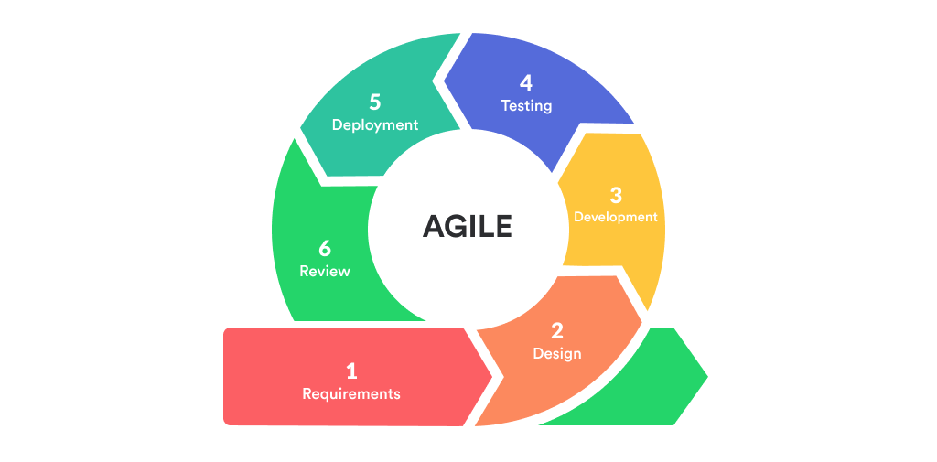

**Figure 1: Phase Agile Methodology**

3.1 Discovery and Requirements Gathering

Discovery and Requirements Gathering known as phase of methodology agile that for development of a health bracelet project. This is to revolutionized the wearble devices that have emerged as valuable tools for monitoring and improving personal health. This phase is to successful implementation of agile methodology throughout the project lifecycle

The Discovery and Requirements Gathering phase is the first step in an Agile project's lifecycle.Objective if this phase if to identify what needs,expectations and goals of project health bracelet and concise project requiment.This phase set of stage for collabration,communication and share understanding among the project members what to do

3.2 Analysis And Design Phase

An analysis is performed during the analysis and design phase of the smart health wristband system to find the appropriate business logic and methodology for the design. This phase also includes the design stage, which follows a top-down technical approach. Various diagrams, such as the context diagram, entity relationship diagram (ERD), circuit diagram, and flowchart, are used in this scenario to describe how the smart health bracelet would work, from receiving input to processing and providing the final output.

During the analysis phase, requirements are obtained and the smart health wristband system's objectives are understood. This entails determining the target consumers' demands and the problem domain. The system's major functionalities, inputs, outputs, and restrictions are discovered and documented through this research.

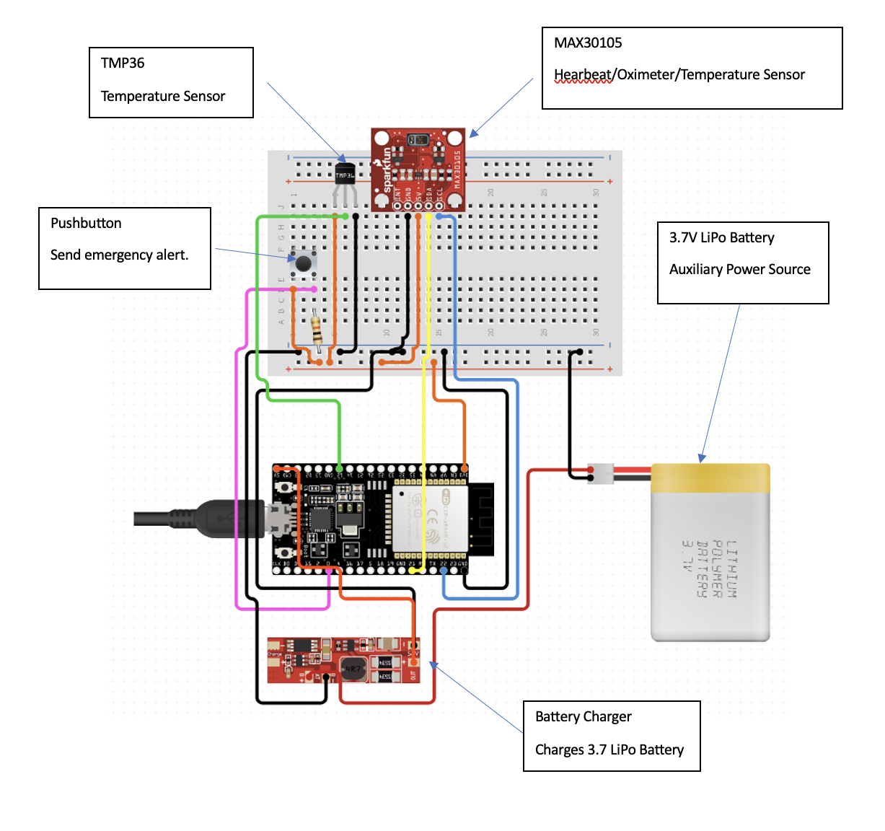 **Figure 2: Circuit Diagram**

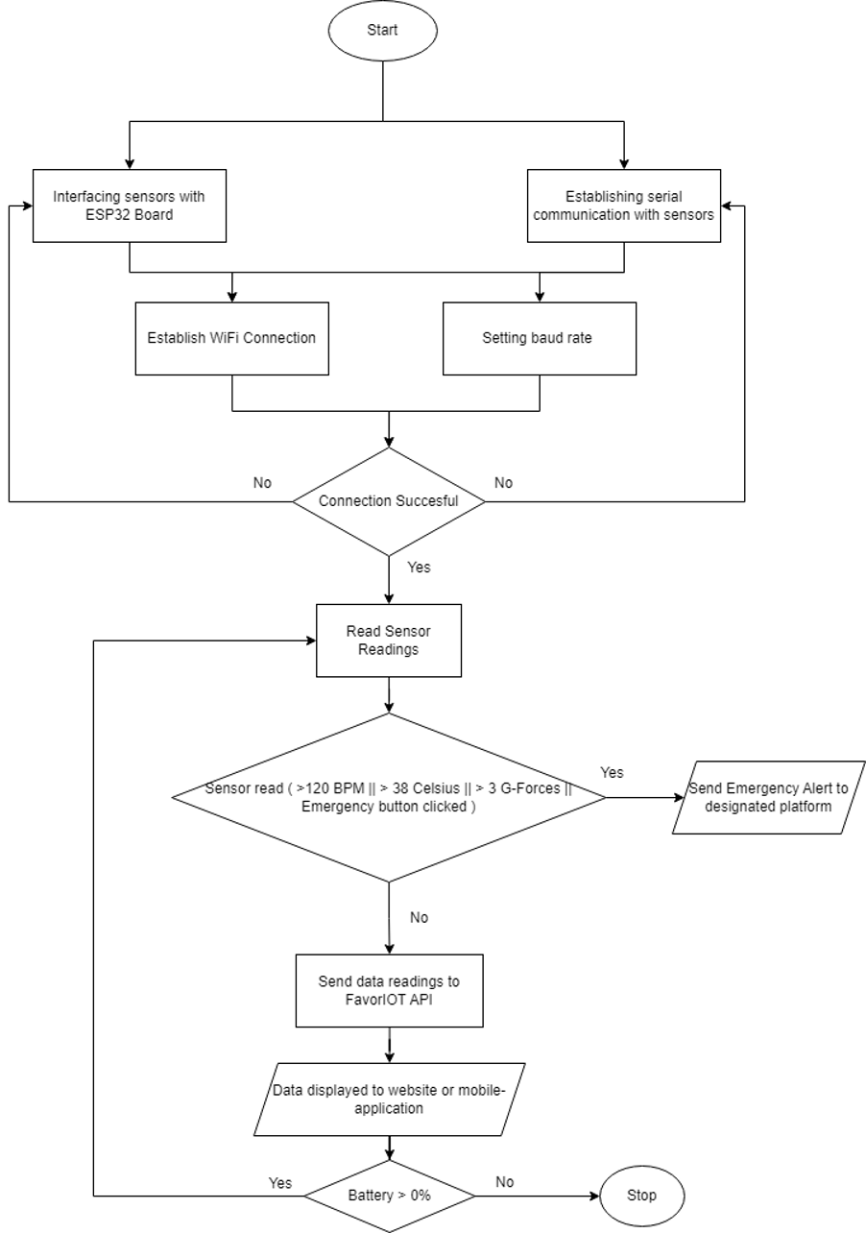

**Figure 3: Flowchart Diagram**

The Arduino will be used as the main controller of the projects that executes all the codes for this project to be run. The jumper wires connect the LED with the Arduino to act accordingly as the program intended. The designing phase will take place first to make sure the project can be presented in a small consumer model and properly showcase the idea of the project. The next step will be the assembly phase which includes wiring and building of housing for the electronics components to make sure all of it is in one place. The continuation of the process is the coding phase where Arduino IDE are used to code and compile the code into the Arduino. After all the technical aspects have been cleared, the assembly of the projects based on the design planned will take place.

The development phase is where the designer and developers begin to work on their project, which seeks to provide a functional product. The product will go through several rounds of development, thus it will have simplistic, minimum functionality. During this phase, the functionality that is needed in this project will be implemented. All the hardware and software that were prepared such as Arduino IDE, MIT application, LED, Bluetooth, and others were used in this phase.

Implementation phase produces the result of the above phases of this project. The authors have completed, connected, and fixed the components at the development phase according to the guideline. Iteration testing was performed and evaluated.

3.3 Development

After analysis and design, the project can begin coding and implementation. All planning, component specifications, and design documents for the project's first iteration, including the temperature sensor, heartbeat sensor, emergency button, heart rate monitoring, impact and fall detection, and notification functionalities, have been coded. The smart health bracelet will be implemented unit by unit, tested to assure functionality, and then integrated and combined into a cohesive, fully functional band.

Developers will code each smart health wristband system component during implementation. This requires translating the design specifications of the temperature sensor, heartbeat sensor, emergency button, heart rate monitoring, impact and fall detection, and notification functionalities into a hardware and software-executable programming language. Coding standards and best practises ensure codebase maintainability, readability, and reusability.

3.4 Testing

The testing phase of smart health bracelet development is crucial for ensuring its accuracy, reliability, and performance in measuring health and fitness data. This phase involves functional testing to validate the intended functionality of the bracelet, including its sensors and features such as temperature, heartbeat, emergency button, and notifications. Performance testing is conducted to ensure the accuracy and dependability of these sensors, comparing their readings with calibrated devices or medical standards. Compatibility testing is also important to ensure the bracelet works seamlessly across various platforms and devices, uncovering any issues related to data synchronization, connectivity, or performance. Thorough testing guarantees precise and trustworthy data, improving the overall user experience and effectiveness of health and fitness monitoring.

3.5 Integration and Deployment

3.6 User Feedback and Iteration

This project will develop the prototype of the smart health bracelet and the design behind it as well to make it function. The functionality of this project is by integration with other devices. Enable integration with other popular health and fitness devices, such as smartwatches, fitness trackers, and mobile apps. This integration allows users to have a centralized view of their health data and track their progress across Blynk platforms. With health monitoring, the bracelet should include various health monitoring features such as heart rate monitoring, temperature and oxygen levels. These readings are instantly transmitted to the user's mobile phone through a dedicated application.

.

# Result and Discussion

4.1 Result

Smart health bracelets are dependent on sensors in order to collect data linked to a person's health and fitness metrics. These parameters include heart rate, blood pressure, and steps taken each day. It is imperative to put these sensors through tests that evaluate not just their precision but also their durability. Because of this, it is necessary to compare the results obtained from the bracelet's sensors with those obtained from recognised measurement devices or well-established reference standards. Comparing something like a heart rate sensor, for instance, to a heart rate monitor that is intended for use in a medical setting is one way to ensure that the findings that the sensor provides are accurate.

Compatibility testing ensures that the intelligent health bracelet will function without any problems across a wide range of computing platforms, mobile operating systems, and electronic gadgets. This comprises assessing whether or not the companion app or software of the bracelet is compatible with a number of electronic devices, such as mobile phones, tablets, and personal computers. For example, a mobile phone must be compatible with a personal computer. When an application is put through compatibility testing, any problems that may exist in terms of synchronisation of data, connectivity, or performance can be uncovered across a number of different platforms.

4.2 Discussion

The success of any project heavily relies on effective supervision and guidance. During the course of our group project, we had the fortunate opportunity to collaborate with Supervisor Ts. Inv. Dr. Shelena A/p Soosay Nathan, whose invaluable support, expertise, and dedication played a pivotal role in our project's progress and ultimate success. This essay aims to highlight the significance of our encounter with Dr. Shelena, as she became an indispensable asset in helping us navigate the complexities of our project and ensuring its completion.

Throughout the project, Dr. Shelena's guidance was instrumental in shaping our ideas and streamlining our approach. She encouraged open discussions and brainstorming sessions, fostering an environment where everyone felt comfortable sharing their thoughts and concerns. By actively listening to our perspectives, she challenged us to think critically, promoting innovative solutions to complex problems. Her vast expertise allowed her to provide insightful feedback, enabling us to overcome hurdles and move forward with confidence.

Our encounter with Supervisor Ts. Inv. Dr. Shelena A/p Soosay Nathan was nothing short of transformative for our group project. Her passion, guidance, and expertise became the cornerstone of our progress. Dr. Shelena's ability to nurture our individual growth, coupled with her meticulous project management skills, made her an invaluable asset throughout our project journey. Her unwavering dedication to our success instilled in us a newfound confidence and motivation. As we reflect upon our time working with Dr. Shelena, we are grateful for the knowledge and skills she imparted, which will undoubtedly shape our future endeavors.



Figure 4 : Discussion with Dr Shelena

# Conclusion

In conclusion, the objective to develop a product that uses the IoT concept was achieved by producing a new model of wearable device which is able to give many benefits for people to stay healthy and encourage them. Through the testing, this project was proven to reach the expected outcome which fulfilled the objective of this project. As for the future improvements, a few recommendations such as adding few sensors and other features would be considered in the project to develop a better product for people stay healthy.

# Acknowledgement

# References

[1] Xu Y. Swot Analysis of Domestic Market of Wearable Sports Equipment Based on Internet of Things Technology[C]//2015 International Conference on Artificial Intelligence and Industrial Engineering. Atlantis Press, 2015.

[2] Larnyo, E.; Dai, B.; Larnyo, A.; Nutakor, J.A.; Ampon-Wireko, S.; Nkrumah, E.N.K.; Appiah, R. Impact of Actual Use Behavior of Healthcare Wearable Devices on Quality of Life: A Cross-Sectional Survey of People with Dementia and Their Caregivers in Ghana. Healthcare 2022, 10, 275.

[3] Devos, P.; Jou, A.M.; De Waele, G.; Petrovic, M. Design for personallized mobile health applications for enhanced older people participation. Eur. Ger. Med. 2015, 6, 593–597.

[4] Arduino IOT Smart Patient Monitoring system with BLYNK Durian UNO (Enhancement Of Arduino UNO),” Arduino IOT Smart Patient Monitoring system with BLYNK Durian UNO (Enhancement Of Arduino UNO). https://mybotic.com.my/arduino-iot-smart-patient-monitoring-system-with-blynk-durian-uno-enhancement-of-arduino-uno

[5] “Pulse Oximeter! Measure Heart Rate and Oxygen Saturation using Max30102, Arduino and Oled Display,” YouTube, Jun. 14, 2021. https://www.youtube.com/watch?v=W_3ljVlt7Sk

[6] “Heart beat monitoring wrist band. Is it possible to make using MAX30102 module ? | Ut Go,” YouTube, May 12, 2020. https://www.youtube.com/watch?v=qI_456UPf5Y

[7] A. B. M Moniruzzaman and D. S. Akhter Hossain, “Comparative Study on Agile software development methodologies,” arXiv.org, Jul. 12, 2013. https://arxiv.org/abs/1307.3356v1